**Gas Sensor (MQ135)**

**Introduction**

MQ135 is one of the commonly used gas sensors in MQ sensor series. It is a Metal Oxide Semiconductor (MOS) type Gas Sensor also known as Chemiresistors as the detection is based upon change of resistance of the sensing material when the Gas comes in contact with the material. Using a simple voltage divider network, concentrations of gas can be detected.

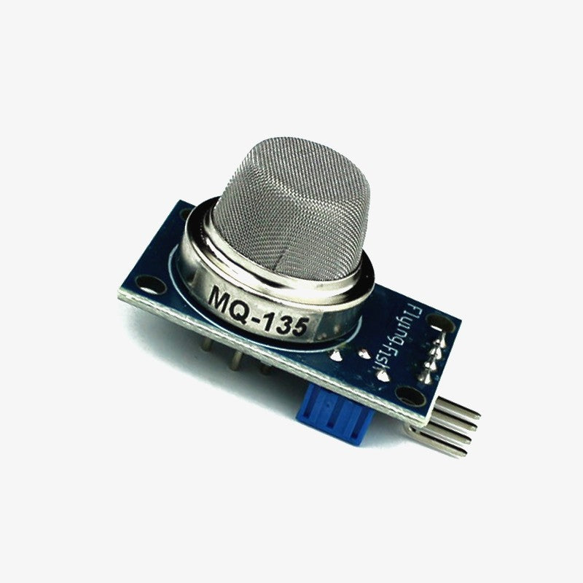

MQ135 Gas Sensor

MQ2 Gas sensor works on 5V DC and draws around 800mW. It can **detect LPG, Smoke, Alcohol, Propane, Hydrogen, Methane and Carbon Monoxide** concentrations anywhere from 200 to 10000ppm.

**Working of MQ135**

The gas sensor module consists of a steel exoskeleton under which a sensing element is housed. This sensing element is subjected to current through connecting leads. This current is known as heating current through it, the gases coming close to the sensing element get ionized and are absorbed by the sensing element. This changes the resistance of the sensing element which alters the value of the current going out of it.

**MQ135 Specifications**

* Operating voltage: 5V
* Load resistance: 20 KΩ
* Heater resistance: 33Ω ± 5%
* Heating consumption: <800mw
* Sensing Resistance: 10 KΩ – 60 KΩ
* Concentration Scope: 200 – 10000ppm
* Preheat Time Over 24 hours

**Pinout of DHT11 Sensor**

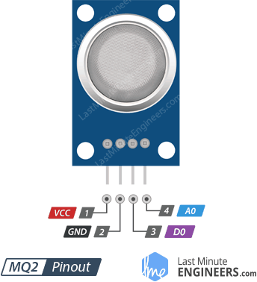

VCC supplies power for the module. You can connect it to 5V output from your Arduino.

GND is the Ground Pin and needs to be connected to GND pin on the Arduino.

D0 provides a digital representation of the presence of combustible gases.

A0 provides analog output voltage in proportional to the concentration of smoke/gas.

**Expected Output**

